Fraction Quantifiers

🥧 What Are Fraction Quantifiers (Types of Numerical Quantifiers)?
# Source: AI Source: Provided by: [Data Path: Persons Table -> ID Column: 1, Name_En Column: Motasem Essam] -> From: [ChatGPT] on [7/28/2025]
Fraction quantifiers express part of a whole — a portion or segment of something.
They can refer to countable or uncountable nouns, depending on context.

✅ Common Fraction Quantifiers:
# Source: AI Source: Provided by: [Data Path: Persons Table -> ID Column: 1, Name_En Column: Motasem Essam] -> From: [ChatGPT] on [7/28/2025]
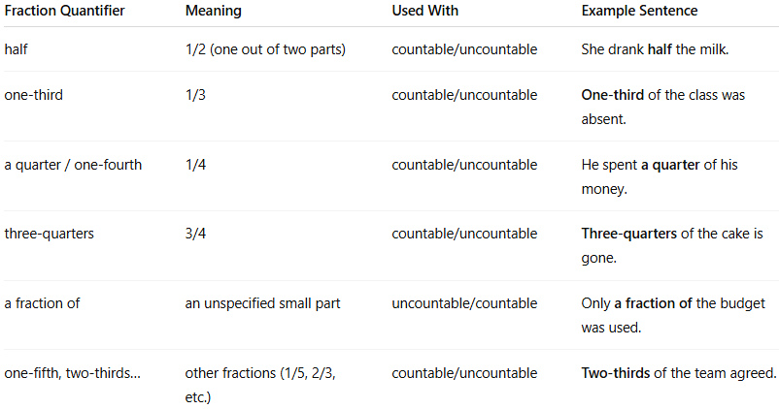
Fraction Quantifier | Meaning | Used With | Example Sentence
half | 1/2 (one out of two parts) | countable/uncountable | She drank half the milk.
one-third | 1/3 | countable/uncountable | One-third of the class was absent.
a quarter / one-fourth | 1/4 | countable/uncountable | He spent a quarter of his money.
three-quarters | 3/4 | countable/uncountable | Three-quarters of the cake is gone.
a fraction of | an unspecified small part | uncountable/countable | Only a fraction of the budget was used.
one-fifth, two-thirds… | other fractions (1/5, 2/3, etc.) | countable/uncountable | Two-thirds of the team agreed.

🔁 Fraction Quantifiers + "of" Phrase
# Source: AI Source: Provided by: [Data Path: Persons Table -> ID Column: 1, Name_En Column: Motasem Essam] -> From: [ChatGPT] on [7/28/2025]
They often appear in the form:
- [Fraction] + of + [determiner + noun]
  - Half of the students
  - One-third of my salary
  - A quarter of the cake

🧠 Notes:
# Source: AI Source: Provided by: [Data Path: Persons Table -> ID Column: 1, Name_En Column: Motasem Essam] -> From: [ChatGPT] on [7/28/2025]
- Fractions behave like quantifiers but require "of" when followed by a noun.
- Verb agreement depends on the noun after the fraction:
  - Half of the team is ready. (singular collective)
  - Half of the apples are ripe. (plural)

